**Pos-questionnaire**

Thank you for participating in this experiment. We now ask you to take a deep breath, relax, and try to answer this brief questionnaire.

**1)** Enter your subject number *

_________________________

**External Factors**

For questions EF1 to EF3, each answer should be rated as follows:

1 (Strongly Disagree)

2 (Somewhat Disagree)

3 (Neither Agree nor Disagree)

4 (Somewhat Agree)

5 (Strongly Agree)

**EF1)** I found the whole experience environment intimidating. *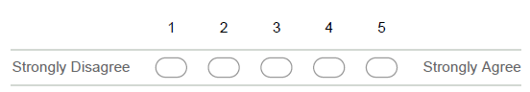

**EF2)** I enjoyed modelling and developing in the experiment. *

**EF3)** I kept getting distracted by other colleagues. *

**Overall satisfaction**

For questions OS1 to OS2, each answer should be rated as follows:

1 (Strongly Disagree)

2 (Somewhat Disagree)

3 (Neither Agree nor Disagree)

4 (Somewhat Agree)

5 (Strongly Agree)

**OS1)** Overall, this particular setup was suitable for solving every task presented. *

**OS2)** I found the documentation available to be sufficient. *

**About VariaMos and FragOP performance**

For questions VF1 to VF12, each answer should be rated as follows:

1 (Strongly Disagree)

2 (Somewhat Disagree)

3 (Neither Agree nor Disagree)

4 (Somewhat Agree)

5 (Strongly Agree)

**VF1)** I found the Feature modelling process easy *



**VF2)** I found the Component modelling process easy *



**VF3)** I found the Component implementation process easy *



**VF4)** I found the Binding modelling process easy *



**VF5)** I found the Configuration process easy *



**VF6)** I found the Derivation process easy *



**VF7)** I found the Customization process easy *

**VF8)** I found the Verification process easy *



**VF9)** Despite of my experience, I found the entire VariaMos and FragOP process easy to learn *



**VF10)** Despite of my experience, I liked to use VariaMos and FragOP *



**VF11)** It is easy for me to remember the main important functionalities of VariaMos and FragOp *



**VF12)** I think VariaMos and FragOP improve code reuse and efficiency for a software product line *



**General Questions**

3 questions about the approach

**G1)** In general, how easy was learning to use VariaMos and FragOP to develop the experiment? *



**G2)** In general, do you think VariaMos and FragOP is an efficient tool that could improve the developers’ productivity? *



**G3)** In general, how was your satisfaction when using VariaMos and FragOP? *



**Specific Questions**

5 Specific questions about VariaMos and FragOP

**SQ1)** How many different model views have VariaMos and FragOP (component-based project)? *

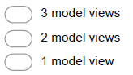

**SQ2)** What is the name of the model were components and features are linked? *

_________________________________

**SQ3)** What is the name of the element that allows to define "variation points"? *

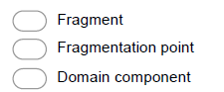

**SQ4)** A fragment only allows to inject code in Java *



**SQ5)** The option "set derivation parameters" allows to define what models should be loaded *



**SQ6)** The "customization points" must contain a begin section (BCP) and an end section (ECP) *



**Leave a comment (optional)**

Thank you so much for completing this questionnaire

If you wish to leave any further comments, please use the following space

___________________________________________________________________________

___________________________________________________________________________

___________________________________________________________________________